QUADRATIC EQUATION (LAB 1) 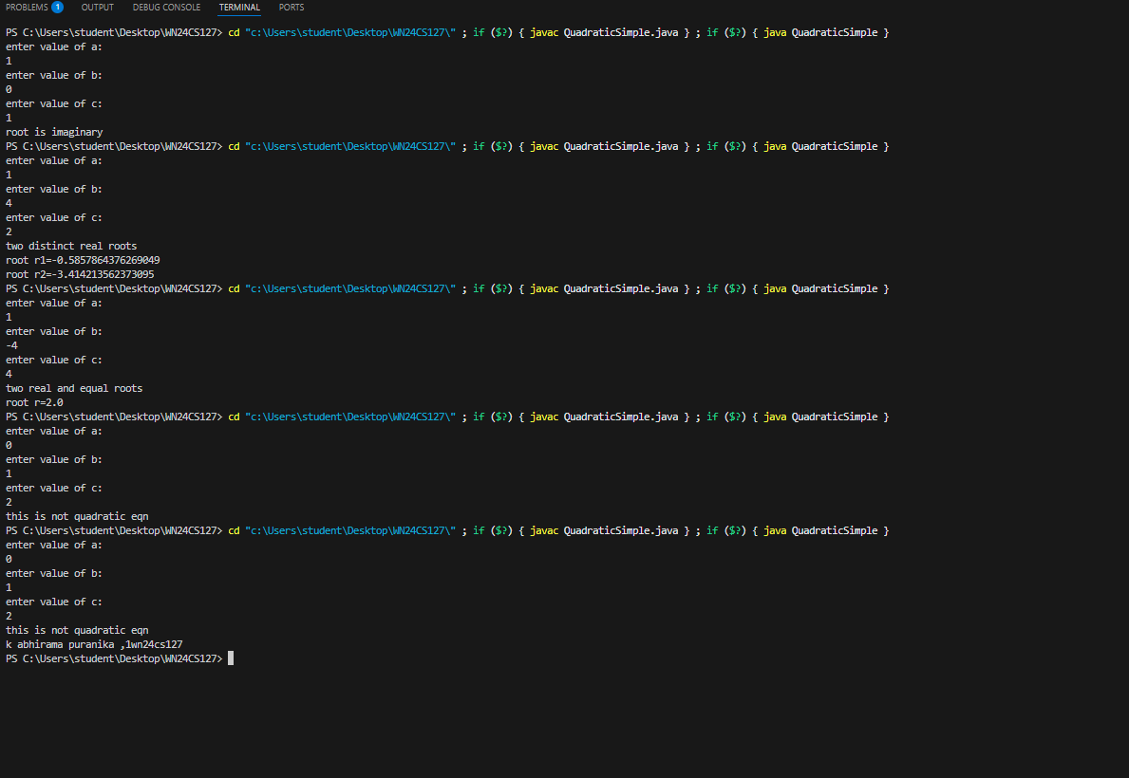K ABHIRAMA PURANIKA
1WN24CS127

